Updated guide version and explained everything I added
I’m suck at edit videos so it will be better for me to write things down instead : D

General Notes & Troubleshooting
General Notes & Troubleshooting
If image recognition fails, take a screenshot of the in-game element, crop it to the specific area (do not use the entire screen), and save it in the corresponding image folder. (While likely unnecessary, you can run a test to be sure) .

Area folders prioritize the highest tier (Tier 1 -> Tier 2 -> Tier 3).
Images within the same tier are prioritized alphabetically by name (A-Z).

Save your script if you are using a strategy different from the default.

All outside of battle configurations are pre-configured. If changes are needed, you should only need to update the in battle script.

I am unable to record videos because screen recording interferes with BlueStacks. Additionally, Also a little bit lazy to write it all out, sorry

I. Getting images 3
II. Getting Coordinates 5
1. Core Control 5
2 Spell & Lastword 5
3 Party & Prepare 7
4 Select Character 8
III. Script Edittor 11
IV. Pause options 13
V. Restart options 14
1. Restart 14
2. Date changed: 16

- Getting images
Select Buff Options: All the select buff options you have, btn_redraw.png, and btn_redraw_dark.png (which appears after using all redraws). Save the buff images in the area folder.
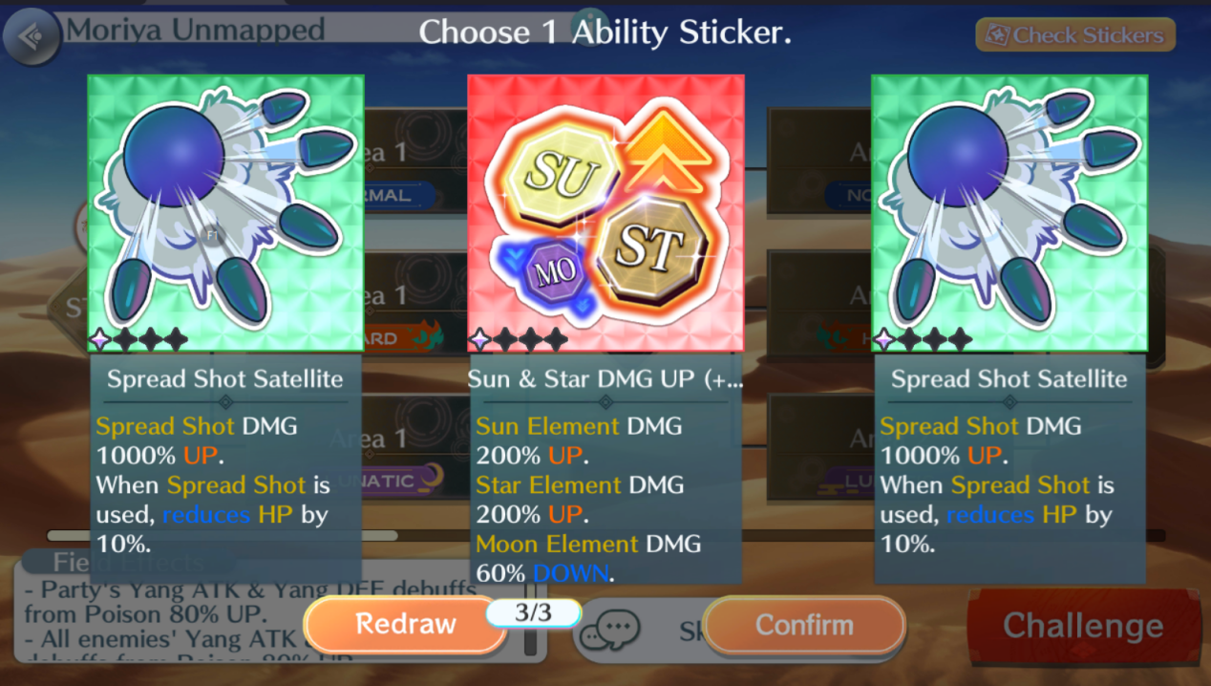
btn_normal.png, btn_hard.png, btn_lunatic.png, and btn_challenge.png
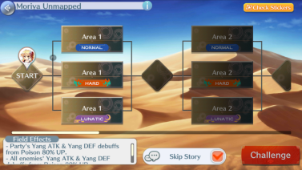
btn_boss_lunatic.png
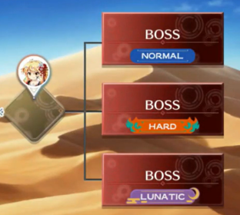
- btn_spell_card.png
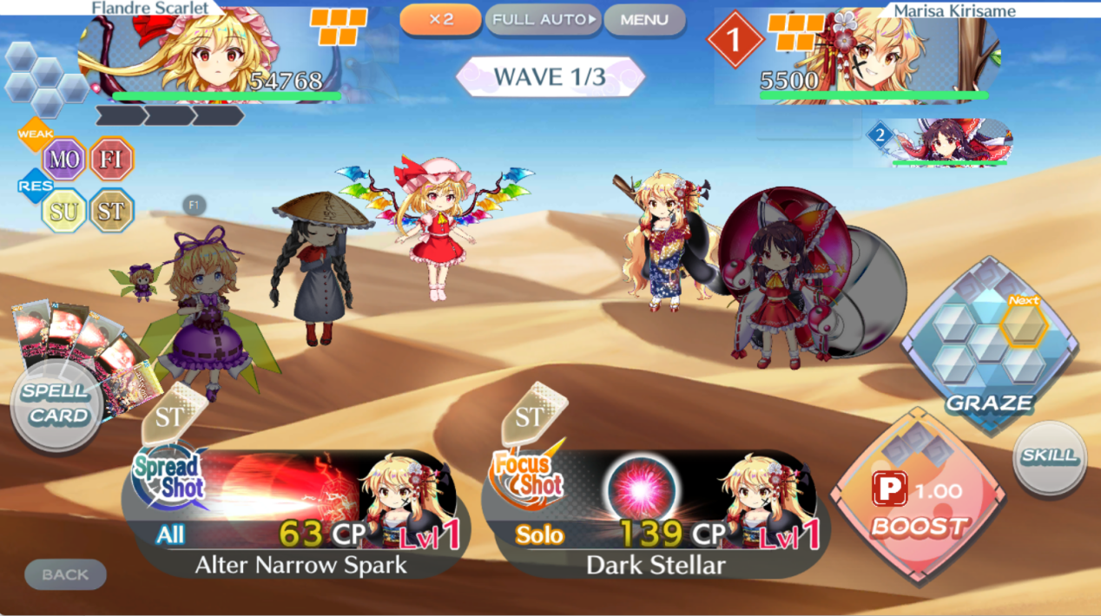
- btn_set_party.png
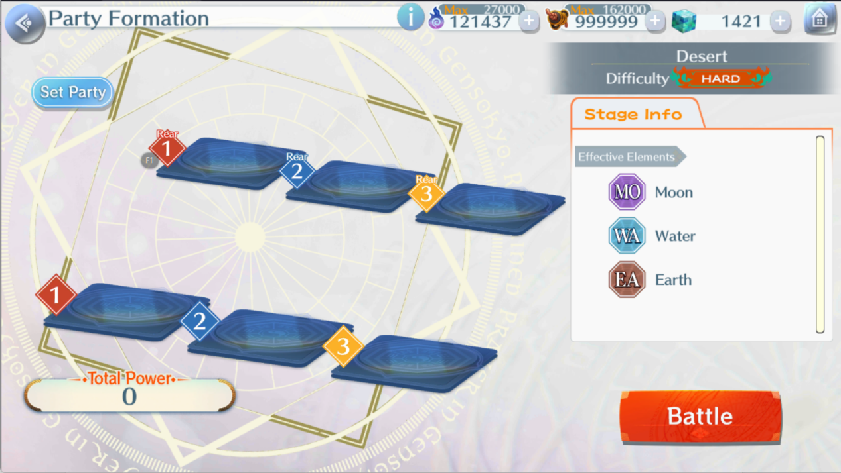
- btn_next.png
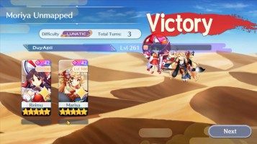
- btn_confirm
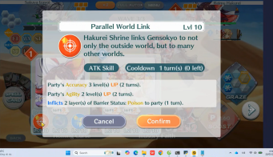
- btn_confirm_party, btn_cancel.png
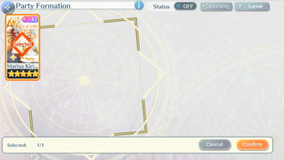
btn_challenge.png
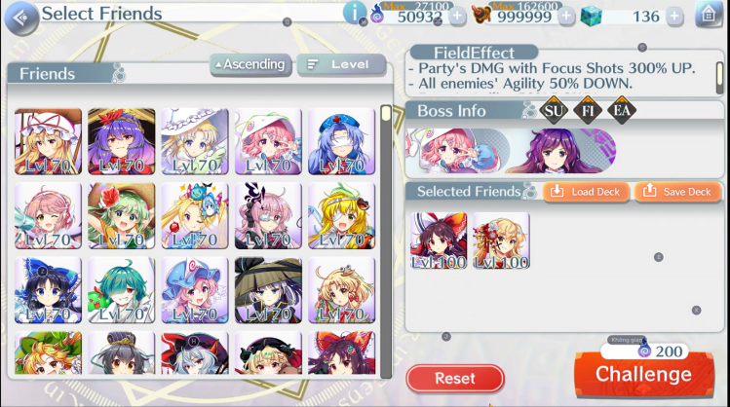

Game_over
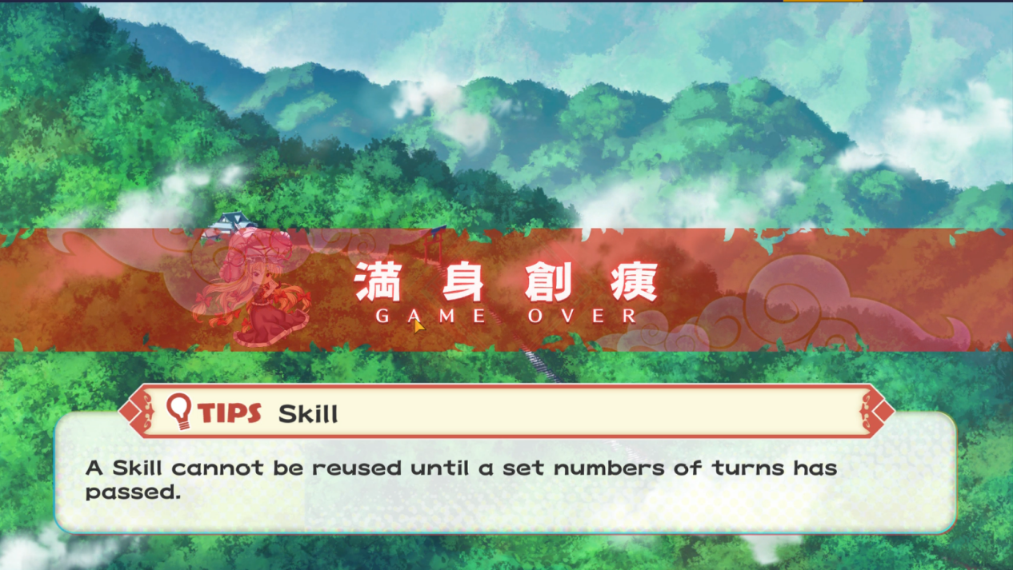

II. Getting Coordinates
Click on the "get button" and click right in the middle of the target button (just as you normally would).

1. Core Control
Battle Screen:
Open/Close Skill, Open Spell, Boost, Spread Shot, Focus Shot.

Open/Close skill
Open spell
Boost
Spread Shot
Focus Shot

2 Spell & Lastword
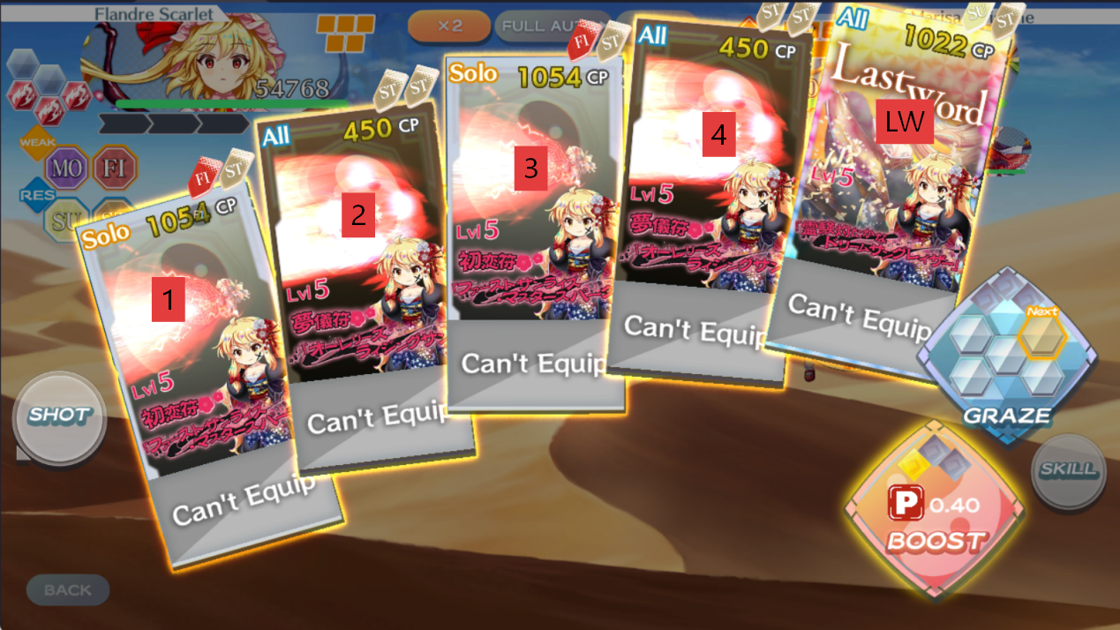
Select buff screen

Random buff: You can pick either one. This is in case you forget to change the image of the buff you have; the script will use this as the final decision.
Skip corner: Use this to click and skip animations, such as receiving a chest or stat buffs increasing. I chose the left corner

3 Party & Prepare
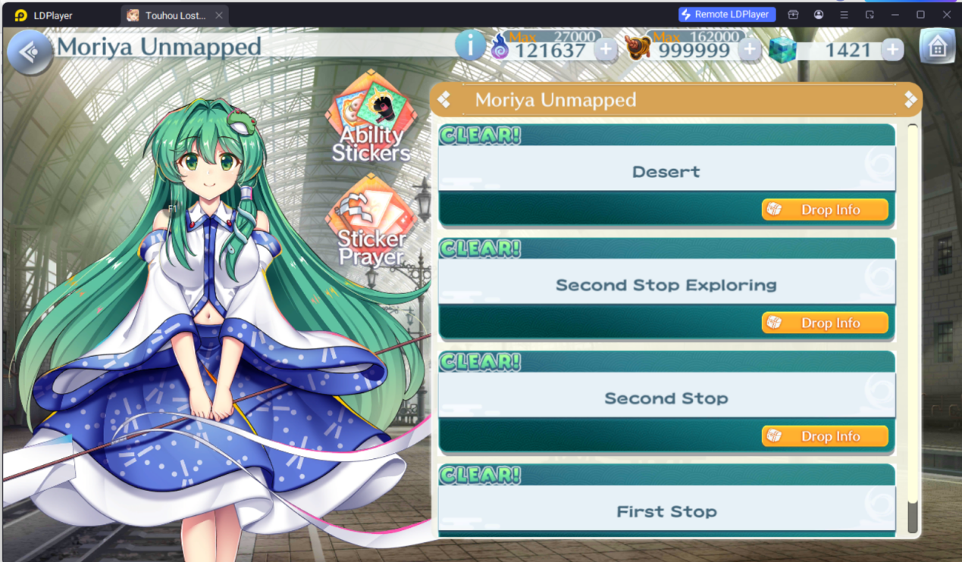

Main stage: The stage you want

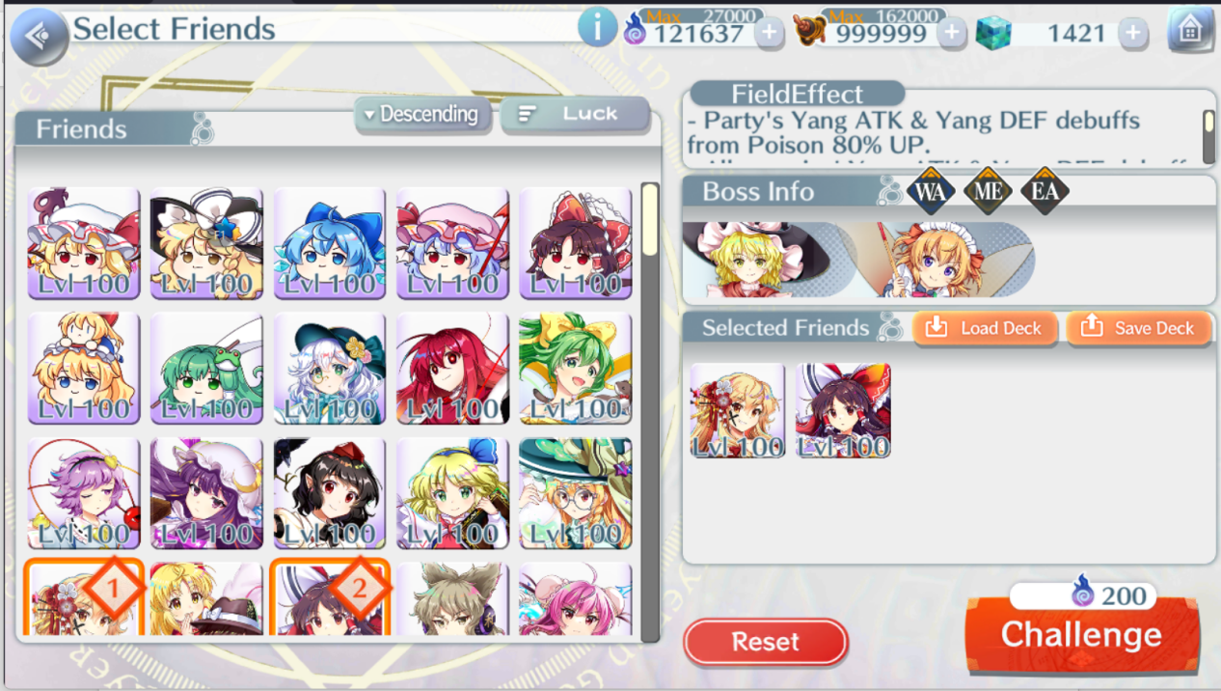

Challenge

Party Formation screen

Party button
Party back
Battle

4 Select Character
Write your unit name for script editor later
Open list
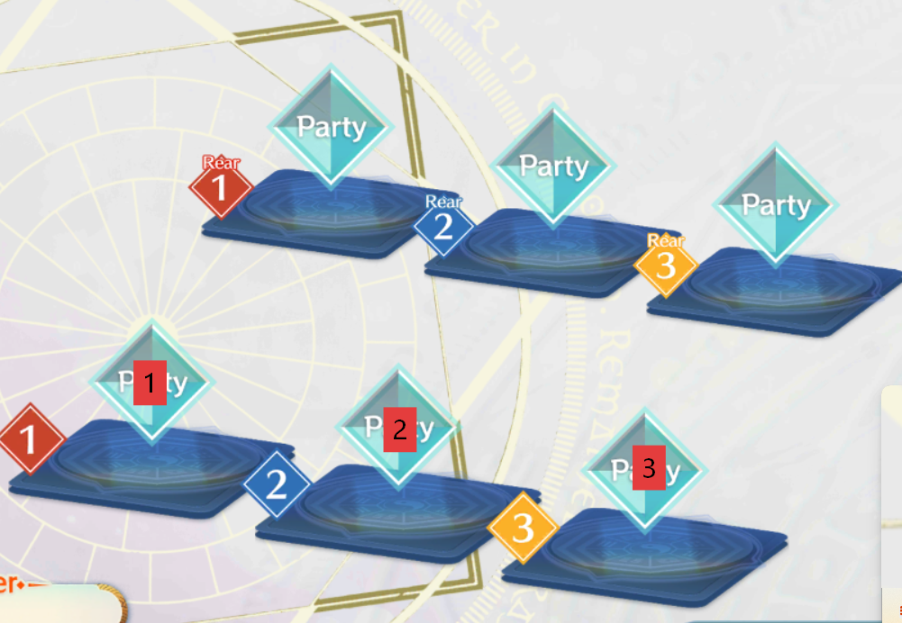

Grid pos
The rightmost unit is Unit 1, and the numbers increase as you move left
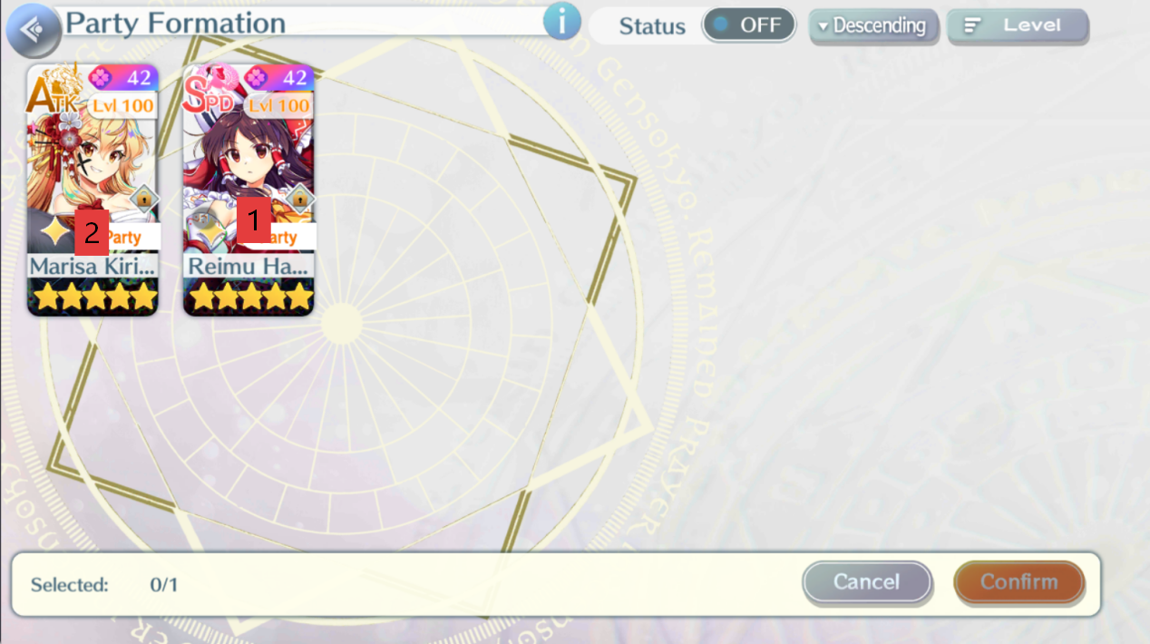
Skill

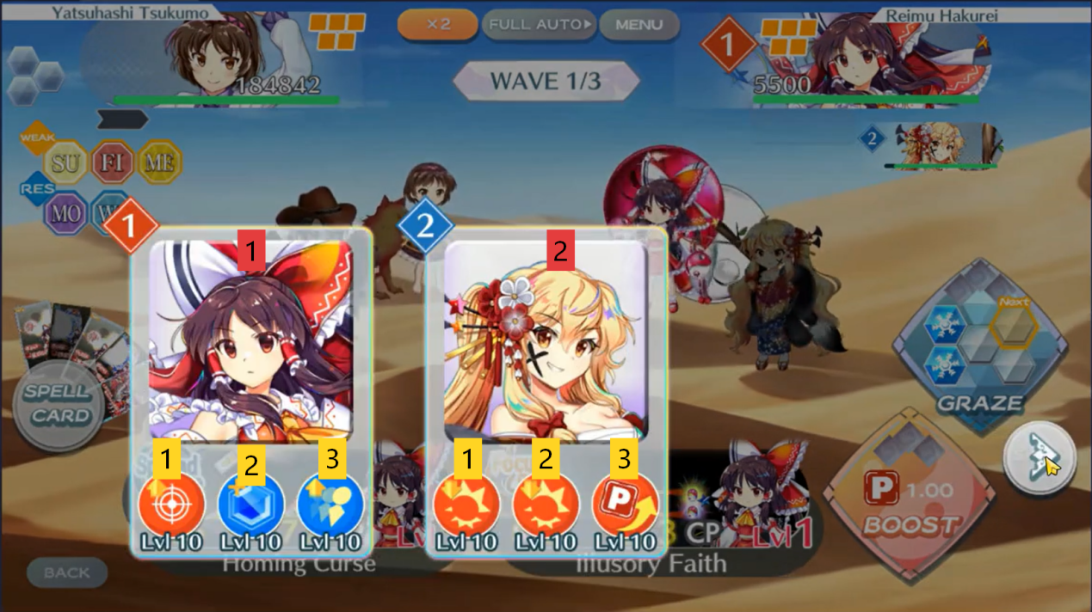

III. Script Edittor
Writing the Script You can edit my script to make this part faster.

Category: Combat

- Click: Self-explanatory; when it clicks a skill, it will also automatically click the confirm button.

- Boost: The number of times to boost.

- Wait for screen:

+ Battle_screen: Waits for the image btn_spell_card.png (it waits every time a turn ends).

+ End_battle_screen: Waits for the image btn_next.png (the result screen).

Category: Party Preparation (Used mainly for team setup in the first area and clicking the battle button)

- Click: Self-explanatory.

- Choose difficulty: It will scan for the image of your choice (e.g., btn_lunatic.png, btn_hard.png). The final area has a different image to prevent the script from confusing it with the Area 6 Lunatic stage, so I had to add one extra image.

- Confirm Party Slot: This is the confirm button in the party formation screen. For some reason, this specific button does not share the same image as the skill/reconnect confirm button.

- Wait for screen:

+ Prepare_screen: Waits for the btn_set_party.png button (waits for your team to load after hitting challenge).

+ Select_party_screen: Waits for the btn_cancel.png button (waits until your units load so they can be clicked).

- Category: Buff & Area Transition
- Click: btn_challenge.png, probably could work for area screen.
- Select buff: Uses image recognition to select a buff, depending on the area folder. It will also click the confirm button.

+ Strict tier 1: Will keep using redraws until a Tier 1 buff appears. If it runs out of redraws, it defaults to the "Any tier" behavior.

+ Any tier: Will not use redraws and simply chooses the highest available tier buff.

- Click skip corner: Clicks the skip corner defined by the Tab 1 coordinates. This is usually used for skipping chest drop animations and buff popups. The target is the number of clicks; each click takes 1 second.

- Start area: Changes the folder to run parallel with the current area.

- End area: Automatically starts the next area; requires no action.

- Wait for screen Buff_screen: Waits for btn_redraw.png and btn_redraw_dark.png.

System Commands

- Wait: Pauses for a few seconds, mainly used for loading screens.

- Separator: Only adds a visual separator to make reading the script easier.

IV. Pause options
By using the pause hotkey/button, you can pause and do whatever you want.
You can continue where you left by clicking the step you want to continue and click the big orange button here
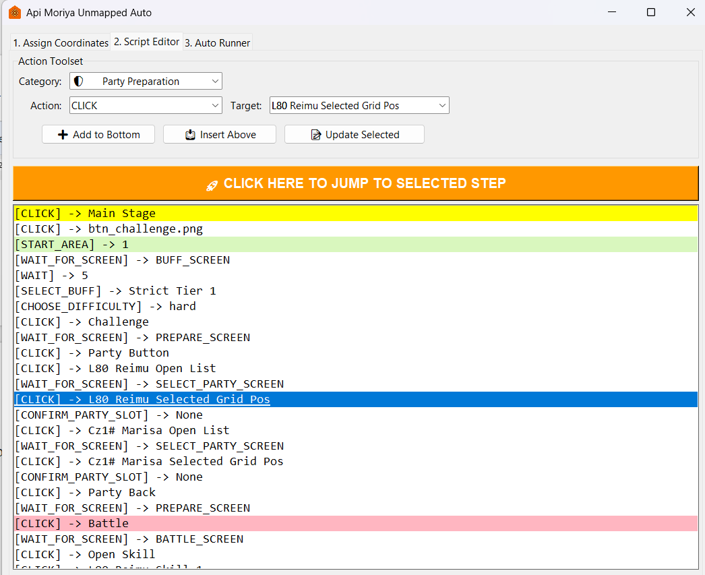

The yellow color indicated where the bot now.

V. Restart options

1. Restart
If your emulator getting freeze (like mine) constantly, you can enable options to restart the game. It also help when the run is stuck somewhere, it can restart the run. If it restart 3 times in 1 run, it will give up current battle to avoid loops.

Here what it would do:
Check the script if it did do something for 90s (can change) ->Click the close emulator coorinate -> btn_close_emu_confirm.png -> Window + D to hide all the app so it won’t click wrong things -> click btn_fullscreen.png -> wait for game_start_screen.png-> click center screen coordinate -> click btn_moriya_unmapped.png -> Main stage coordinate -> challenge coordinate

+ Without smart jump options, it will give up the current battle
+ With smart jump, it will try to continues the current battle, although sometimes it will get the area wrong.

Get coordinate:
In tab 1, in the rescue protocols
Close Emulator: The X button on your emulator
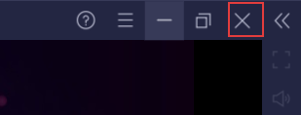
Game desktop icon: icon game on your desktop
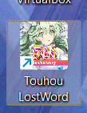

Center screen: Could be anywhere, it just click 1 time to enter the game after loading.
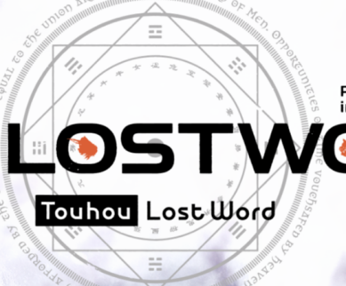
Give up run: Give up button

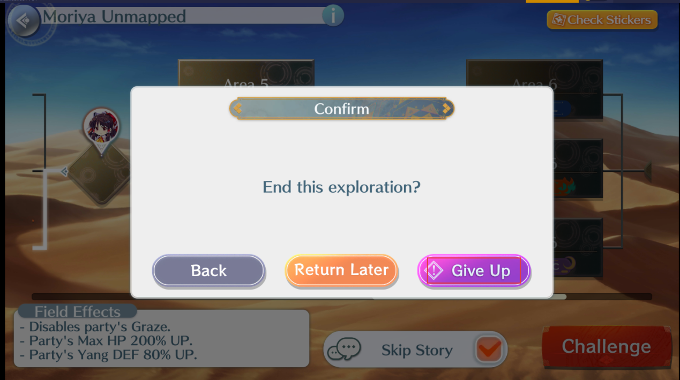

Images:
btn_fullscreen.png

btn_close_emu_confirm.png
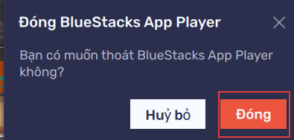
Moriya Unmapped: If it isn’t clear enough

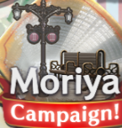

game_start_screen.png
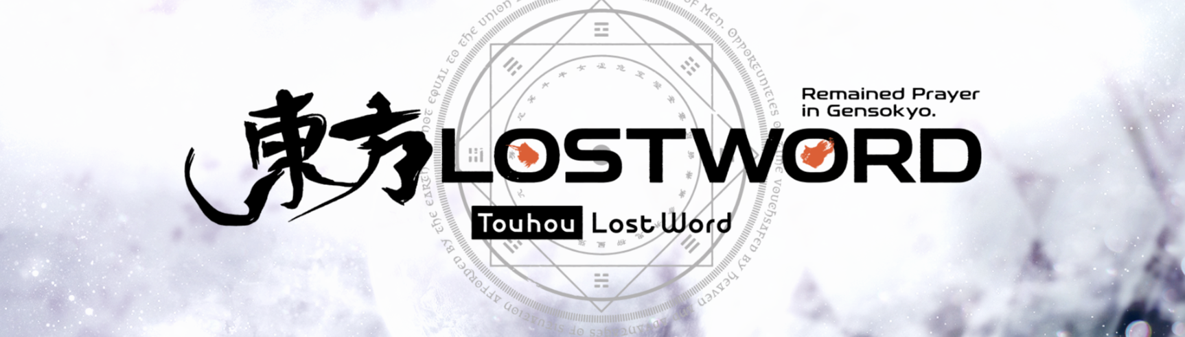

- Date changed:
If this is ticked, it will do exactly like auto rescue, but it will restart 3 time in a row to clear all in in game news, everyonr win....
Probably could do better, but I’m kinda ok with this..

msg_date_changed.png


